MATH5090M Assignment 1
Athang Ghag (201712928)
30/04/2023

Introduction
The information and analysis in this report is based on a dataset of cancer patients. In this report, we analyze the age at which cancer patients die and the various factors affecting it. We explore the relationship between age at which the cancer was diagnosed and the age at death of patients. We also design a new public health intervention, which aims to improve care for cancer patients.

Methodology and Analysis
The given dataset of cancer patients has 210 rows and 18 columns. There are 210 patients and 18 features with information about each patient. There are no missing values in the dataset. The features contain information such as age at which the patient was diagnosed (AgeDiagnosis) and age at which the patient died (AgeDeath) which are given in years in numeric format. There is an unique identity number associated with each patient in the IDnumber column and similarly a site identity number (SiteID) for hospitals where the patient is taking treatment.
The data has categorical binary variables such as Sex, Race, Employment Status, Social Grade Status to give information about patient’s demographics. Moreover, the binary variable HighQualityOfLife shows whether the patient is leading a high quality life or not.
The categorical variable Type shows the type of cancer the patients is diagnosed with such as Kidney cancer, Thyroid cancer, Leukemia, Bowel, Brain, and more. The binary variable Metastases indicates if the cancer is metastasized or not, Stage3or4 indicates if the cancer has progressed to the third stage, MultiSite variable indicates if the cancer has spread to multiple sites, and similarly Remission variable shows if the cancer is in remission or not. The categorical variable Treatment shows the type of treatment the patients is undergoing which include Chemotherapy, Radiotherapy, Immunotherapy, and No Treatment.
The patients are taking treatment at different hospitals. We group by the SiteID to calculate number of patients at each hospital.
Table 1- Number of Patients in each site
SiteID | Number of Patients
1 | 8
5 | 12
6 | 14
11 | 25
13 | 14
16 | 19
17 | 33
19 | 6
20 | 37
21 | 15
22 | 13
25 | 14
There are 12 sites in total. Site 20 has the highest number of patients which is 37 and Site 19 has the lowest number of patients.
We now analyze our target variable AgeDeath and covariate AgeDiagnosis. We plot the histograms of these two variables to explore their behaviour.
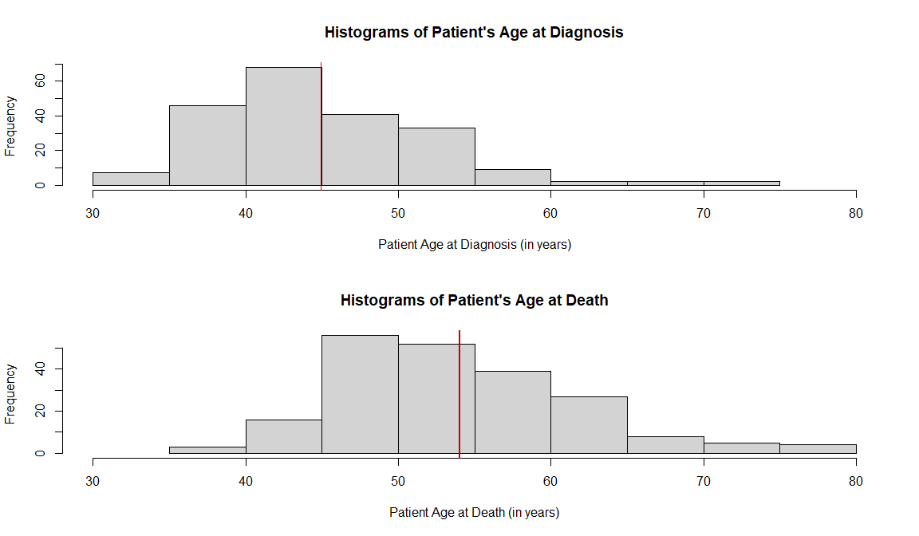
Fig 1- Histograms of Patient’s Age at Diagnosis and Patients Age at Death.
We observe that, the histogram of age at diagnosis is slightly right-skewed. The most frequent diagnosis age falls between the ages of 35 to 50 years with the mean age being around 45 years. 